IST769 Homework Submission Template

Basic Information
Your Name: Holden Herrell
Your SUID: 502591291
Your Email: hwherrel@syr.edu
Date Due: 10/19/2019
Homework #: 3

Instructions
For each answer, please include your answer as text, and any screenshot(s) which demonstrate your answer was executed. Most importantly, make sure to include evidence your answer is correct. This will most likely be a screenshot. If you had issues, problems, or had to make assumptions include them in your answer.

Your Answers:
1.
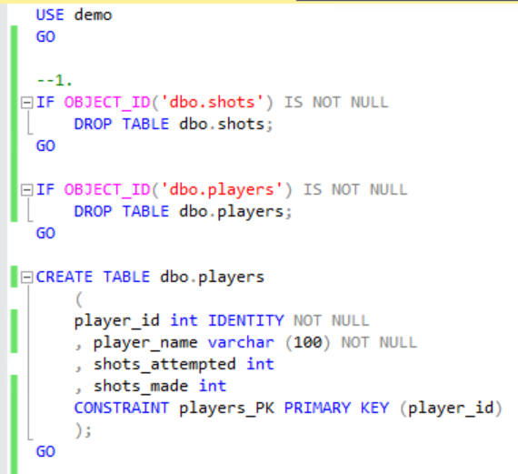
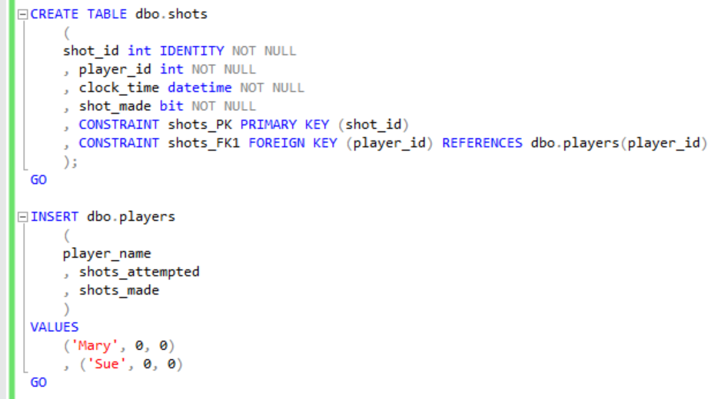
2.
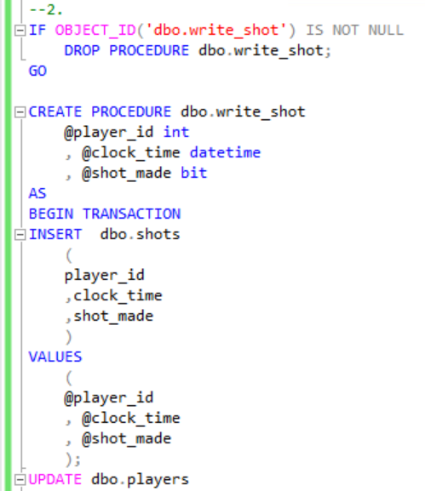
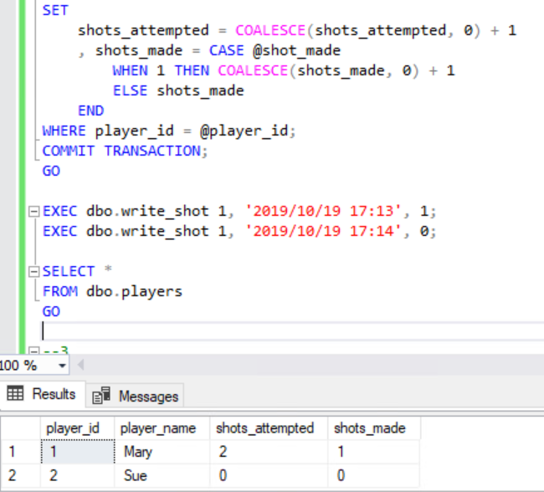
3.
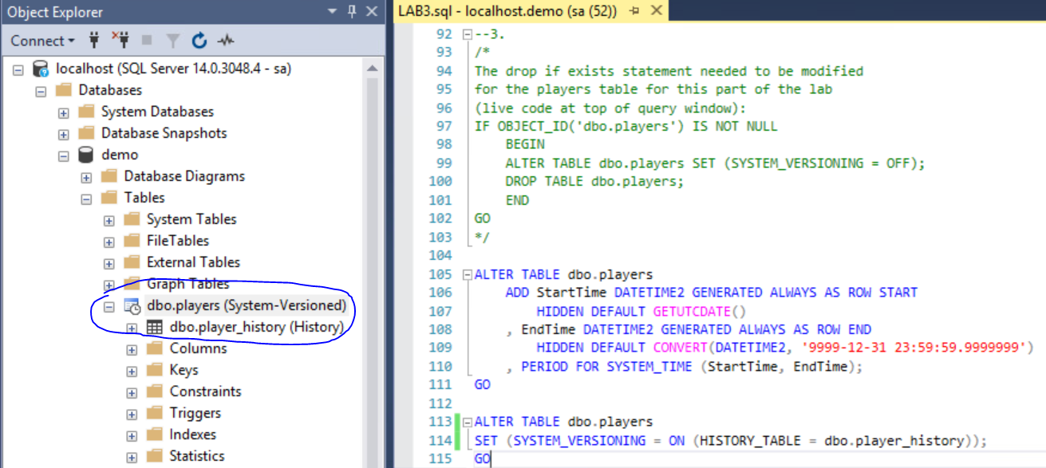

4.
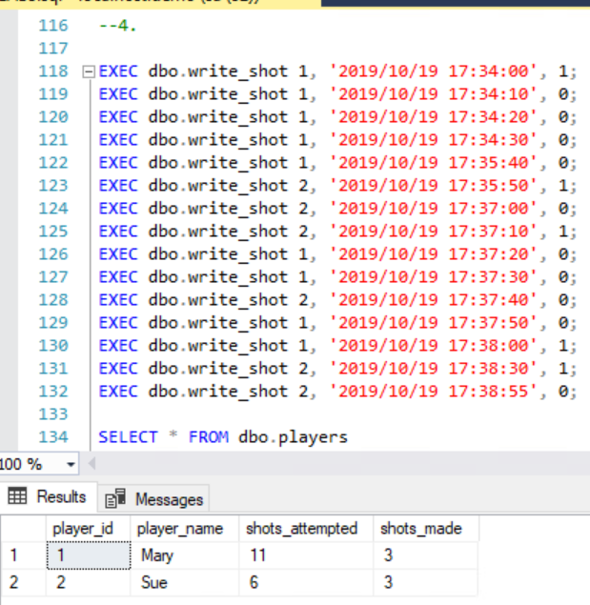

5.
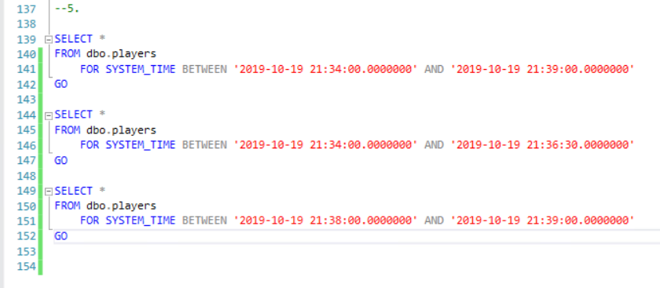
I’m still not 100% sure why the time changes to 21 in the hour instead of 17 when it’s stored in the history table. Really fought this for quite some time (tried changing what times I used several times thinking that was the issue).

